Power Virtual Agents Example

1. Open Power Virtual Agents <https://powerva.microsoft.com>
2. Start trial version
3. Create new bot “NousFirstBot”
4. Go to Topics
5. – Open Greeting and update it
6. Click ‘Go to authoring canvas’ button

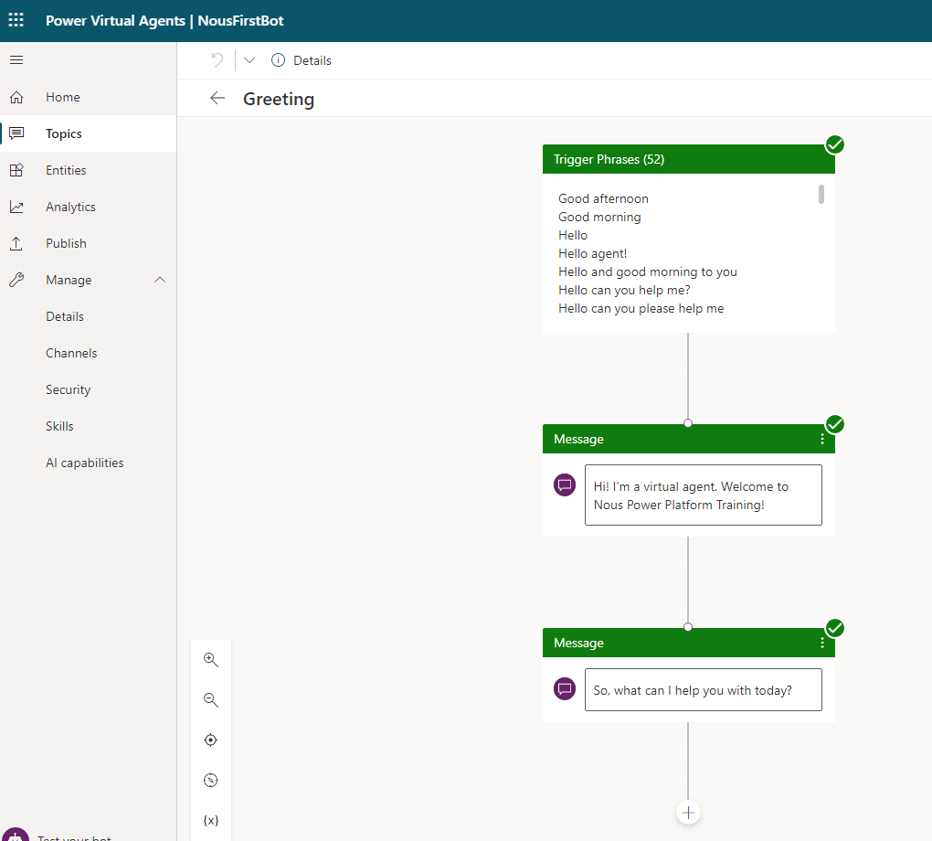

1. – Create new topic
   1. Name: Solutions
   2. Description: Add info about the topic
2. Add Trigger phrases
   1. Technologies you support
   2. Support
   3. Services offer
   4. What we Offer
   5. Licensing
   6. Training
   7. Solutions
   8. Services
   9. Help
3. Save it

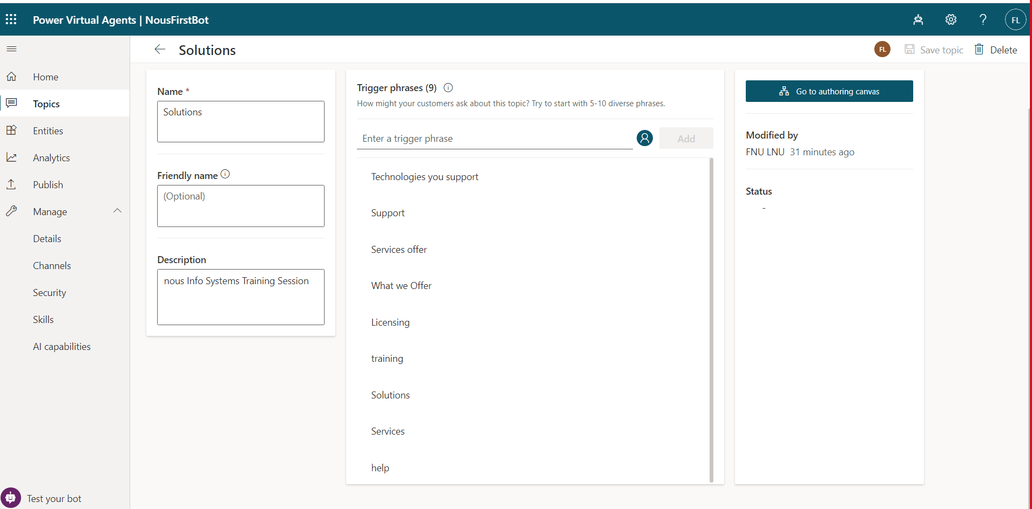

1. Click ‘Go to authoring canvas’ button
2. Its open new window to add steps
3. Add message

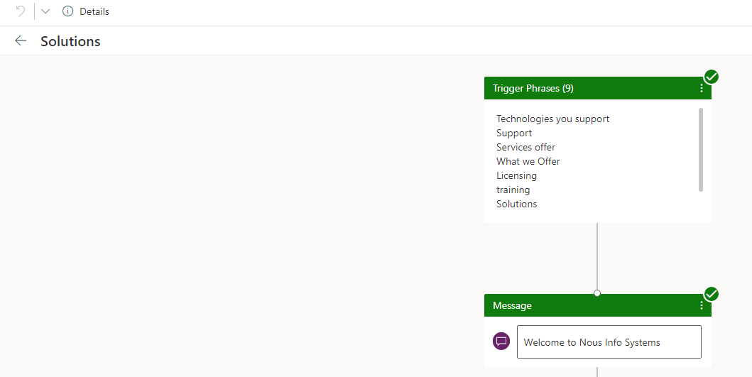

1. Ask a Questions with multiple choice options

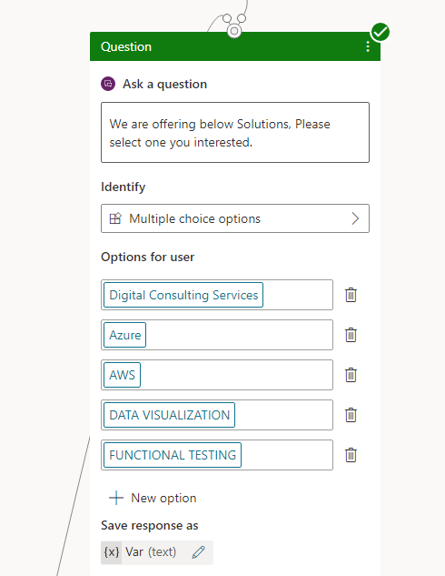

1. It will automatically create all condition, if require modify it
2. Then add messages for all conditions, refer below image

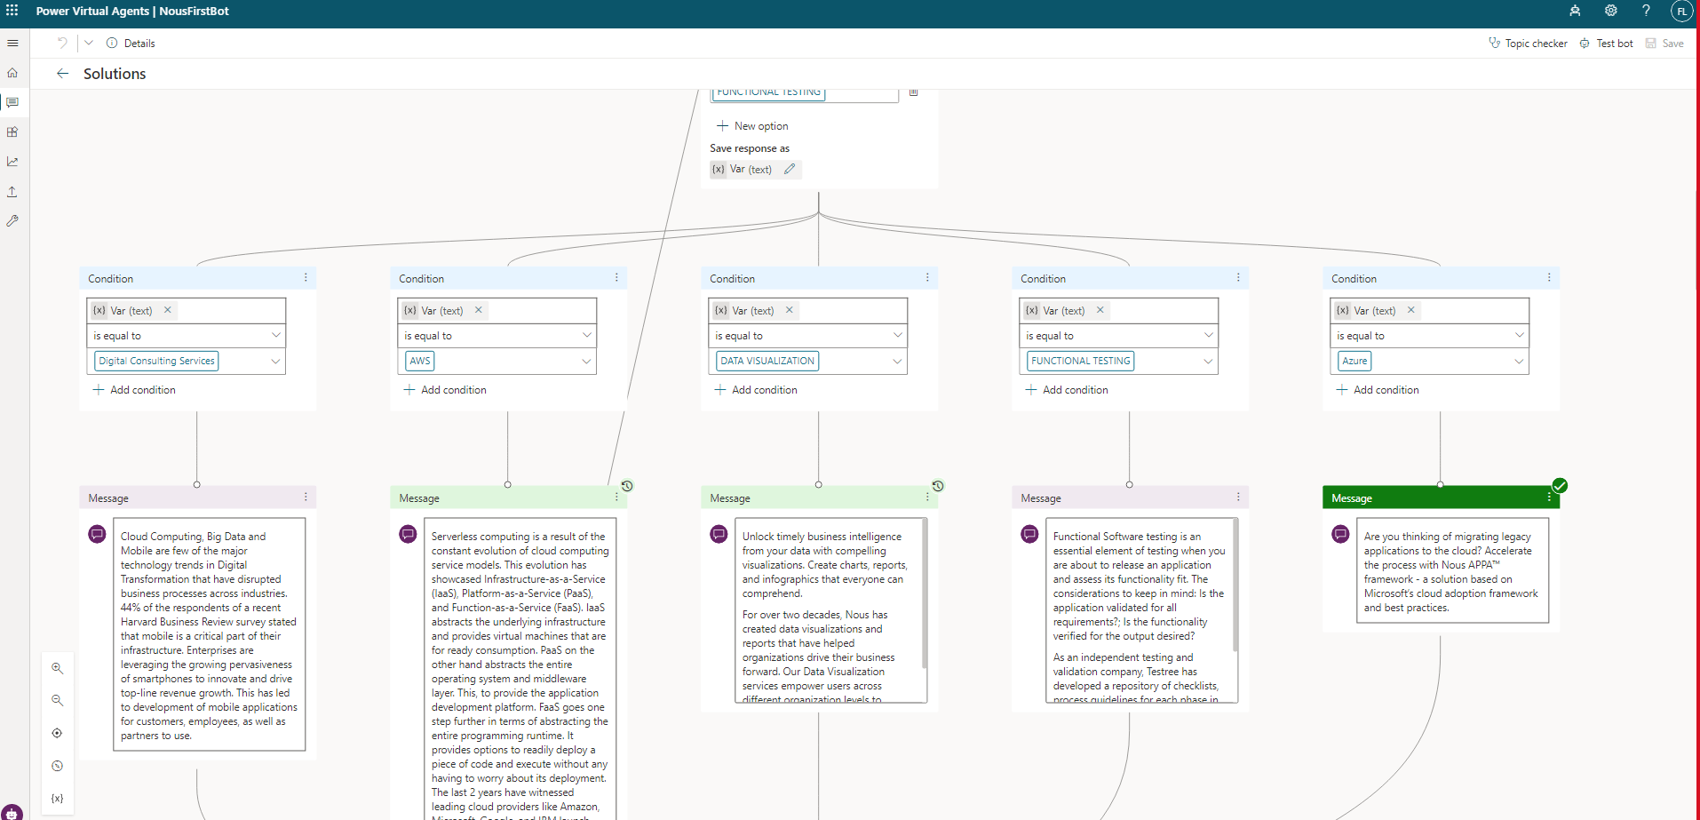

1. Add message and make it available for all conditions
2. Ask Question

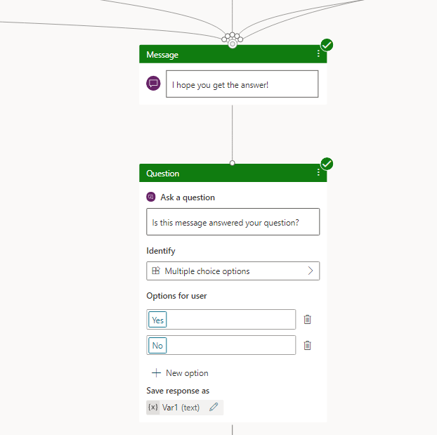

1. Add questions based on Yes / No

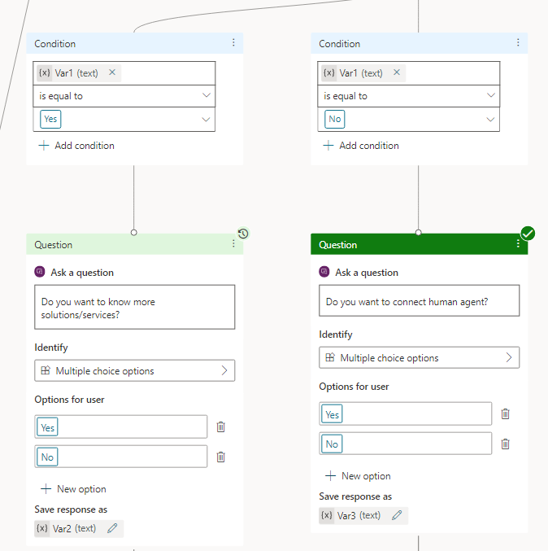

1. Ask questions and based on that redirect it

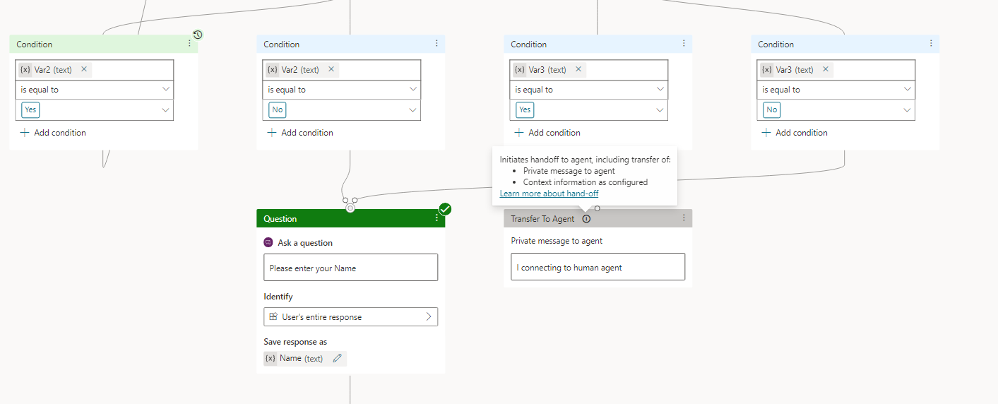

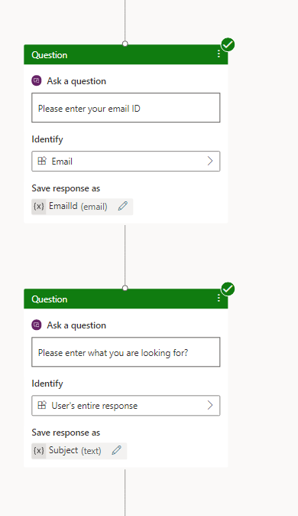

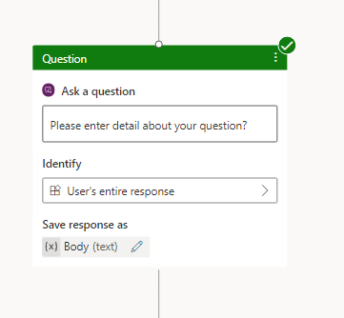

1. Call an action 🡪 Create flow

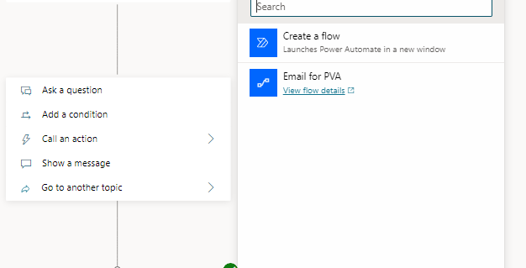

1. Add flow add send email

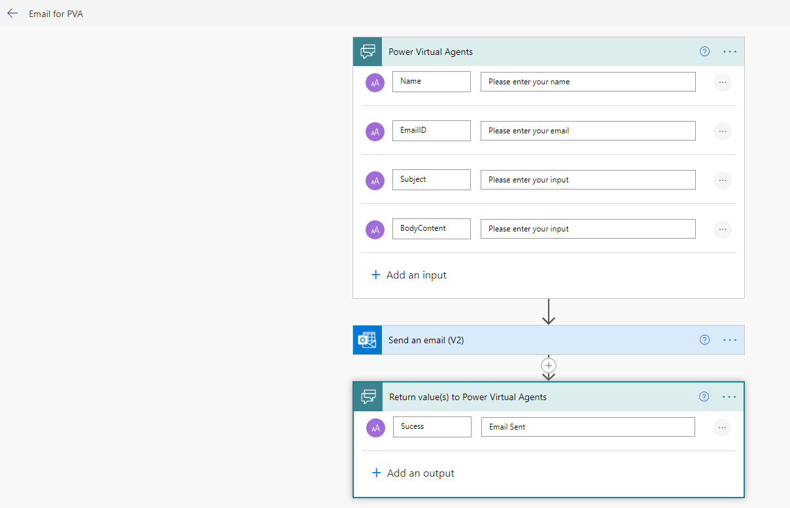

1. Assign the inputs from user to the flow parameters

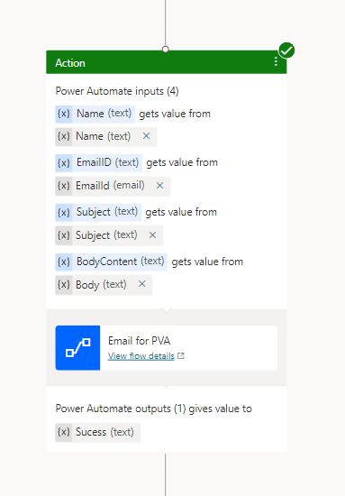

1. Return success or failure message

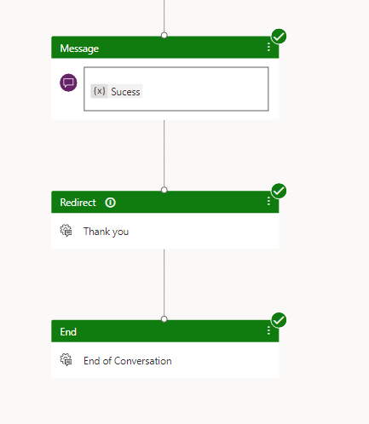

1. Save it
2. Test it using Text bot in left hand side
3. Publish it

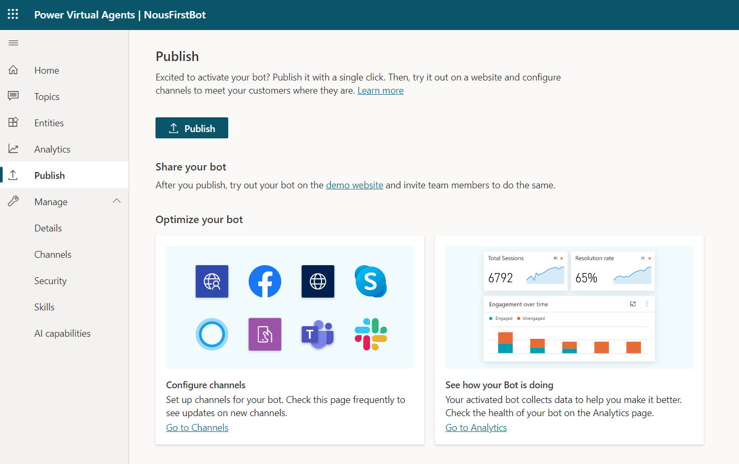

Go to channel in left hand side and publish where you want

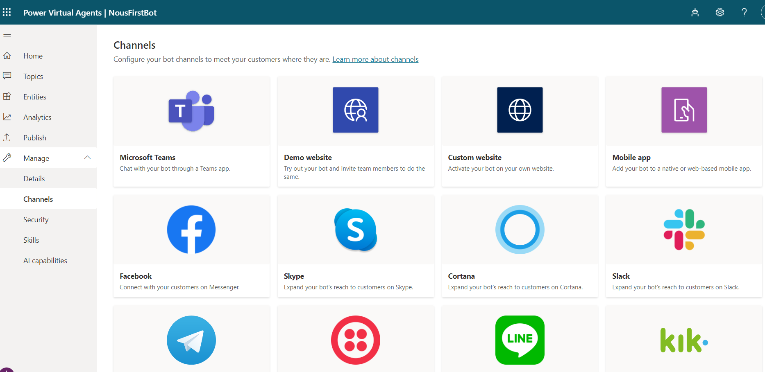

1. 